Module 4 - Test driven development and Logging framework
Exercise 1: Setting Up JUnit

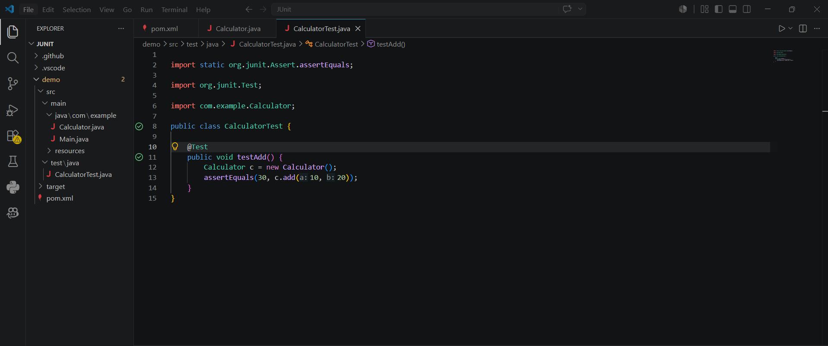

Output
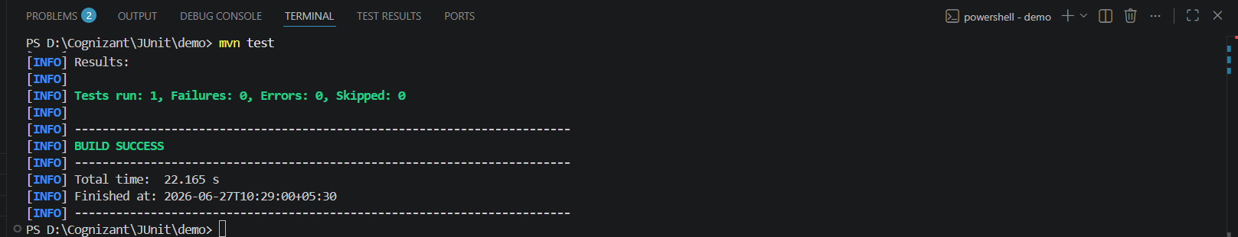

Exercise 3: Assertions in Junit
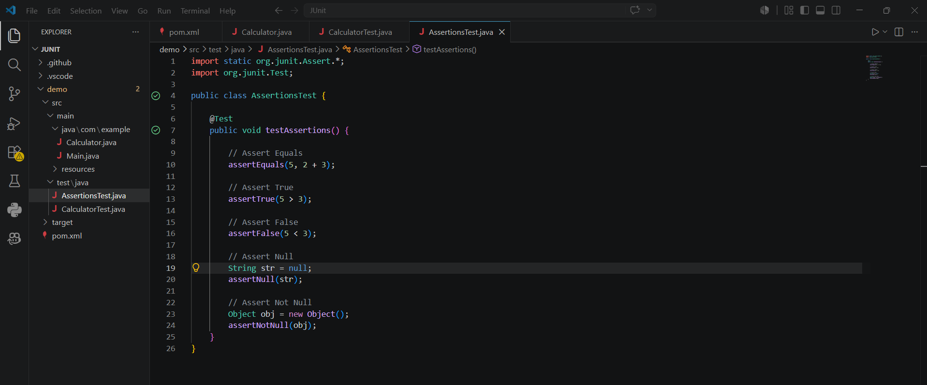

Output
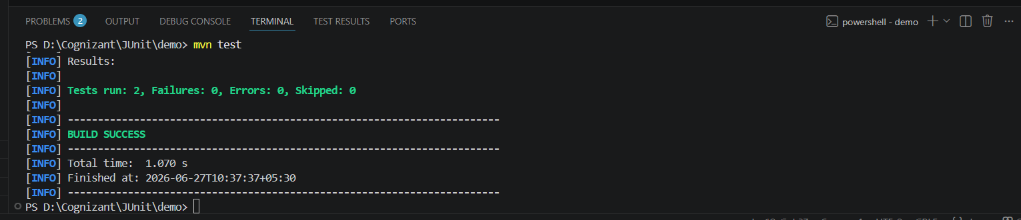

Exercise 4: Arrange-Act-Assert (AAA) Pattern, Test Fixtures, Setup and Teardown Methods in Junit

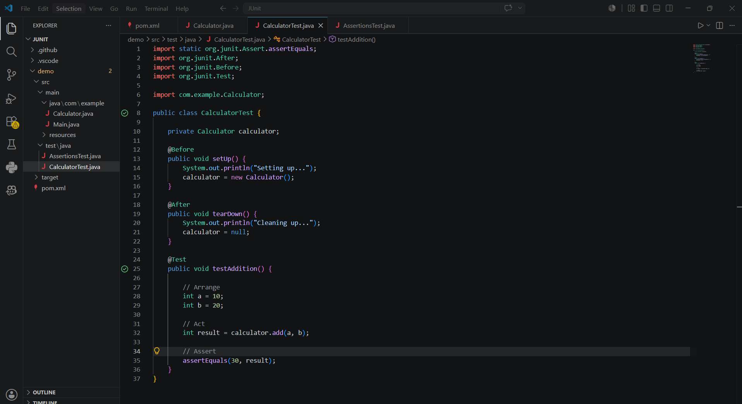
Output:
